Lab no 07: Arithmetic and Logic Operations (ALU)

The purpose of this Lab is to learn to:
- Implement a 2-bits Arithmetic and Logic Operations (ALU) on FPGA. You will write the behavioral description for the ALU using Verilog.
- Connect sub-modules on a top-level module. You will connect the ALU and the seven-segment decoder.
Be aware: In this lab, the seven-segment decoder is written in behavioral description using a case statement, not logical equations like Lab 2.
- Use the switches and seven-segment on the FPGA board to display the output of the ALU.

Parts: -

- Code the behavioral description of the 2-bit ALU.
- Code the behavioral description of the seven-segment decoder.
- Connect the ALU and the seven-segment decoder on the top-level module and run it on FPGA.

Part 1. Code the behavioral description of the 2-bit ALU

One of the core components of a CPU is the Arithmetic and Logic Unit (ALU). This component is responsible for performing the calculations (such as addition) on data when executing a machine code instruction. It is like a simple calculator where you set the inputs and the operation, giving you the result.

In this lab, we will design and build a basic ALU that is capable of eight operations, as follows:

ALU Selection | ALU Operation | ALU Output
000 | ALU_Out = A and B; | On 2 Leds
001 | ALU_Out = A or B; | On 2 Leds
010 | ALU_Out = A + B; | On 1 Seven Segment
011 | ALU_Out = A - B; | On 1 Seven Segment
100 | ALU_Out = A * B; | On 1 Seven Segment
101 | ALU_Out = A > B; | Draw A on Seven Segment
110 | ALU_Out = A < B; | Draw B on Seven Segment
111 | ALU_Out = A == B; | Draw = on Seven Segment

Behavioral description Verilog code for ALU

module ALU ( A, B, ALU_sel, ALU_result);
input [1:0] A,B; // ALU 2-bit Inputs
input [2:0] ALU_sel; // ALU 3-bit Selector
output [3:0] ALU_result; // ALU 4-bit Output
reg [3:0] ALU_result;
always @(*)
begin
case(ALU_sel)
3'b000: // Logical and
ALU_result = A & B;
3'b001: // Logical or
ALU_result = A | B;
3'b010: // Addition
ALU_result = A + B;
3'b011: // Subtraction
ALU_result = A - B;
3'b100: // Multiplication
ALU_result = A * B;
3'b101: // Greater comparison
ALU_result = A > B? 4'b1010:4'b1011;
3'b110: // lower comparison
ALU_result = A < B? 4'b1011:4'b1010;
3'b111: // Equal comparison
ALU_result = A == B? 4'b1100:4'b0000;
default: ALU_result = 4'b0 ;
endcase
end
endmodule

Part 2. Code the behavioral description of the seven-segment decoder

Seven segments decoder using the Case statement. A seven-segment display decoder takes a 4-bit data input BCD and produces seven outputs to control light-emitting diodes to display a digit from 0 to 9 and comparison outputs.

Behavioral description Verilog code for seven segments decoder.

module sevenSegments (bcd,dec);
input [3:0]bcd;
output reg [6:0] dec;
always@(bcd)
begin
case(bcd)
4'b0000 : dec = ~7'b1111110; // 0
4'b0001 : dec = ~7'b0110000; // 1
4'b0010 : dec = ~7'b1101101; // 2
4'b0011 : dec = ~7'b1111001; // 3
4'b0100 : dec = ~7'b0110011; // 4
4'b0101 : dec = ~7'b1011011; // 5
4'b0110 : dec = ~7'b1011111; // 6
4'b0111 : dec = ~7'b1110000; // 7
4'b1000 : dec = ~7'b1111111; // 8
4'b1001 : dec = ~7'b1111011; // 9
4'b1010 : dec = ~7'b1110111; // A
4'b1011 : dec = ~7'b1111111; // B
4'b1100 : dec = ~7'b1001000; // =
default : dec = ~7'b1111110; //0 default
endcase
end
endmodule

Part 3. Connect the ALU and the seven-segment decoder on the top-level module and run it on FPGA

module ALU_to_decoder (A, B, ALU_sel,Segmentleds,leds);
input [1:0] A,B; // ALU 2-bit Inputs
input [2:0] ALU_sel; // ALU 3-bit Selector
output [6:0] Segmentleds; //Seven segment leds
output [1:0] leds; // Leds
wire [3:0] ALU_result; // ALU 4-bit Output
// Instantiation of the ALU
ALU ALU_dut(A, B, ALU_sel, ALU_result);
// Instantiation of the Seven segment //Display Output on Seven segments
sevenSegments sevenSegments_dut (ALU_result,Segmentleds);
assign leds = ALU_result [1:0]; //Diplay Output on Leds
endmodule

Run the integrated design (ALU + Decoder) on FPGA.
- Refer to Lab 2 to program the FPGA by Quartus
- Use DE10-lite kit, Altera MAX 10 based FPGA board
- Check the DE10-lite user manual (Here) for pin assignment.
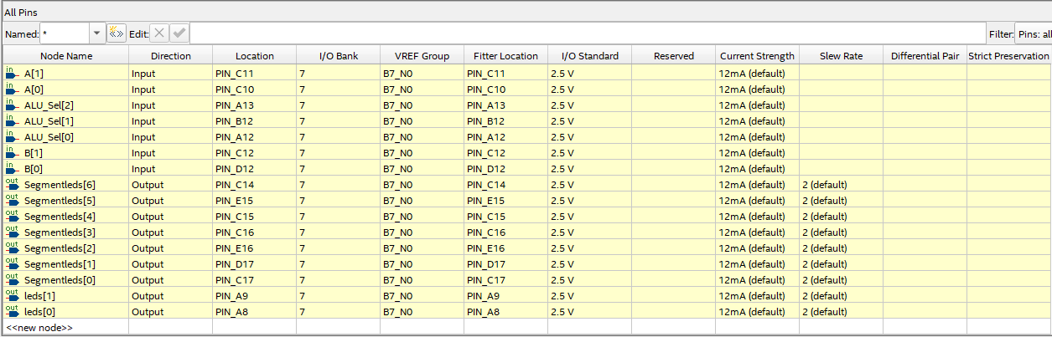
Note: Inputs/Outputs Assignment, Open the Assignment tab, click on Pin Planner, and assign pins as shown in the figure below.

